**Section 1–4A: Solving Equations**

**Expression vs. Equation?**

An equation is a statement that two expressions are equal. In other words, equation must contain an equal sign and an expression does not.

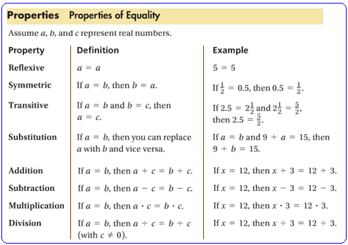

Solving an equation that contains a variable means finding all values of the variable that make the equation true. Such a value is a **solution of the equation**. To find a solution, isolate the variable on one side of the equation using *inverse operations*. **Inverse operations** are operations that **“undo”** each other. Addition and subtraction have this inverse relationship, as do multiplication and division.

**Example 1: Solving a Multi-Step Equation**

What is the solution of $3\left(2x-1\right)-2\left(3x+4\right)=11x$?

$3\left(2x-1\right)-2\left(3x+4\right)$ = $11x$ Distributive property.

$6x-3-6x-8$ = $11x$ Combine like terms.

$-11$ = $11x$ Divide each side by 11.

$-1$ = $x$ Symmetric property.

$x$ = $-1$

It’s always a good practice to double check your answer:

$3\left(2\left(-1\right)-1\right)-2(3\left(-1\right)+4)$ = $11(-1)$

$3\left(-3\right)-2(1)$ = $-11$

$-11$ = $-11 √$

An equation does not always have one solution. An equation has no solution if no value of the variable makes the equation true. An equation that is true for every value of the variable is an **identity**.

**Example 2: Equations with No Solution and Identities**

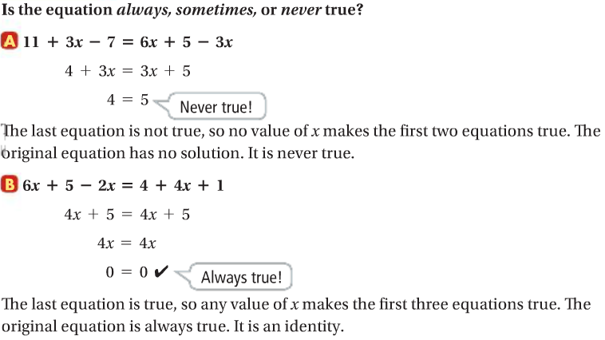

**What does it mean for an equation to be sometimes true?**

An equation is sometimes true if it is true for some, but not all, values of the variable [Example 1].

A **literal equation** is an equation that uses at least two different letters as variables. You can solve a literal equation for any one of its variables by using the properties of equality. You solve for a variable “in terms of” the other variables.

**Example 3: Solving a Literal Equation**

Solve the equation for *x*: $c\left(x+2\right)-5=b(x-3)$ Distributive property.

$cx+2c-5=bx-3$ Gather all the *x* terms on one side.

$cx-bx=-2c+5-3$ Factor out the *x* and combine like terms.

$x\left(c-b\right)=-2c+2$ Divide each side by $(c-b)$.

$x=\frac{-2c+2}{c-b}$